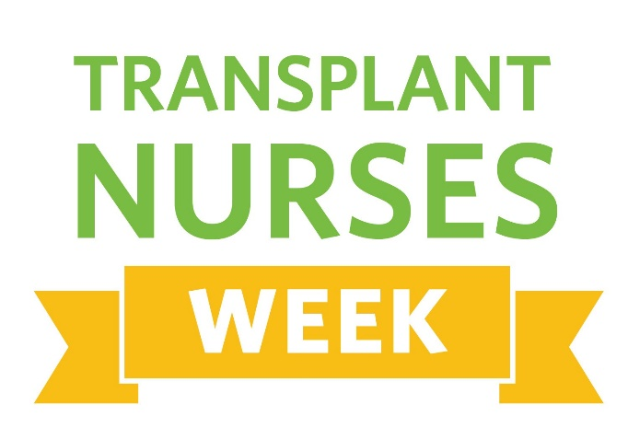
April 24 – May 1, 2023
Join the International Transplant Nurses Society (ITNS) as we recognize amazing transplant nurses everywhere from April 24 – May 1, 2023.
The International Transplant Nurses Society (ITNS) created Transplant Nurses Week to raise awareness of the unique contributions transplant nurses make in the lives of the people with whom they work, especially their patients.
As awareness of this important profession grows, ITNS is committed to creating more opportunities for nurses, healthcare professionals, organ donors and recipients, and their families to show their appreciation for the incredible care transplant nurses provide around the world.
Visit the ITNS website for tools and ideas on how to celebrate and spread the word to your colleagues, patients, and families about Transplant Nurses Week. This is an excellent opportunity to show support to those who make an impact each and every day to transplant patients and their families, as well as their colleagues.
Share your stories on social media and use the “sticker” we had created for Transplant Nurses Week and use #transplantnursesweek.
Twitter: @ITNSnurses
Facebook: @InternationalTransplantNursesSociety
This Photo by Unknown Author is licensed under CC BY-NC
Instagram: @TransplantNurses

